SALES PERFORMANCE
DASHBOARD
Using Microsoft Power BI
PROJECT REPORT
NAME: NIVEDITHA AANAND
ROLL NO: E25FA059
TOOL USED: MICROSOFT POWER BI

1

Introduction
This project presents an interactive Sales Performance Dashboard created in Microsoft Power BI. The report combines sales transactions with product, store, city, state, customer, salesperson, order and date information. It is designed to provide a clear view of revenue, profit, order volume and quantity sold, while allowing users to explore performance across products, locations, store types and time periods.

Objectives
- Summarise overall business performance using KPI cards for revenue, profit, orders and quantity.
- Track monthly revenue movement across the available reporting period.
- Compare revenue across product categories and store types.
- Examine revenue by city and by individual store.
- Review store-level revenue and profit performance.
- Provide interactive filters for year, store type, product category, state and customer segment.

Dataset Description
The dashboard is supported by nine CSV tables. The fact_sales table contains transaction-level sales measures.
The dimension tables provide descriptive information used to group and filter those transactions:
- fact_sales – sales records including order, date, customer, product, store and salesperson keys, quantity, revenue, cost, profit, discount and tax.
- dim_order – order-level details such as order date, status, channel, payment status, shipping and order amount.
- dim_product – product names, categories, subcategories, brands, prices and stock information.
- dim_store – store names, store types, city links and store operating details.
- dim_city and dim_state – geographic details for store locations.
- dim_customer – customer details and customer segments.
- dim_salesperson – salesperson and employee information.
- dim_date – calendar attributes including date, month, quarter and year.

Data Preparation
The CSV files were reviewed and connected through their corresponding ID fields. The fact_sales table was used as the primary source for the displayed revenue, profit and quantity calculations. Product, store, city and date dimensions were used to organise the transaction values for the dashboard visuals. The date table covers 12 January 2024 to 11 January 2026.

Measures / KPI Values Used
The dashboard presents the following measures. Values below reflect the full dataset represented in the supplied screenshots:

Dashboard Components
The completed report brings together KPI cards, charts, slicers and a store performance table. The main dashboard screenshot below shows the overall view of the sales data.
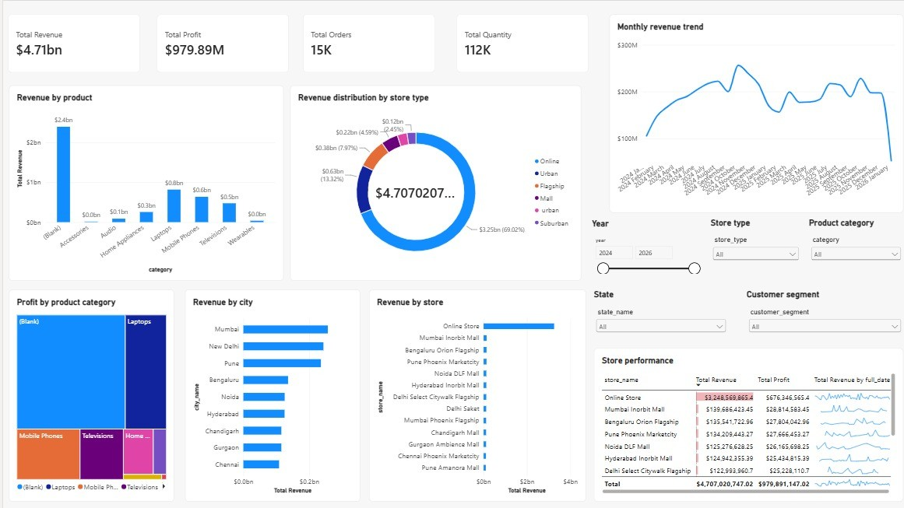

Sales Performance Dashboard – Overall View
The top KPI cards display total revenue of $4.71bn, total profit of $979.89M, 15K total orders and 112K total quantity. The monthly revenue trend occupies the upper-right section. Revenue by product and revenue distribution by store type are shown in the upper middle area. The lower section compares profit by product category, revenue by city and revenue by store, alongside a store performance table.
The screenshot also shows interactive controls for year, store type, product category, state and customer segment. These filters allow the report to be explored from different business perspectives.

Visual Analysis

Monthly Revenue Trend
The line chart tracks revenue from January 2024 through January 2026. In the CSV-based monthly aggregation, October 2024 is the highest month at approximately $256.36M. Revenue remains substantial through 2025, with a lower January 2026 value because the available date table includes only the first 11 days of that year. The final point should therefore not be compared with complete months without accounting for the shorter period.

Revenue by Product Category
Using fact_sales joined to dim_product, the largest category totals are Mobile Phones ($1,769.42M), Laptops ($1,457.70M) and Televisions ($931.95M). The remaining categories are Home Appliances, Audio, Wearables and Accessories. The supplied screenshot visibly includes a '(Blank)' label in the revenue-by-product visual; the CSV product join assigns all fact rows to a product category, so the blank display label may reflect a visual/model field configuration and should be checked in Power BI.

Revenue Distribution by Store Type
Online stores contribute the largest share, approximately $3.25bn or 69.02% of total revenue. Urban stores contribute about $626.95M (13.32%), followed by Flagship stores at $375.01M (7.97%) and Mall stores at $216.12M (4.59%). The source data also contains a separate store-type value with extra spaces and different letter casing (' urban '), which appears separately in the aggregation unless standardised.

Revenue by City and Store
The city comparison shows Mumbai, New Delhi and Pune as the leading physical city markets in the CSV-based aggregation. The revenue-by-store chart is led by Online Store, followed by Mumbai Inorbit Mall, Bengaluru Orion Flagship and Pune Phoenix Marketcity. The store performance table places total revenue and total profit side by side for each store, making it useful for comparing scale and profitability.

Tooltip View
The tooltip shows the major cards connecting to the dashboard as follows
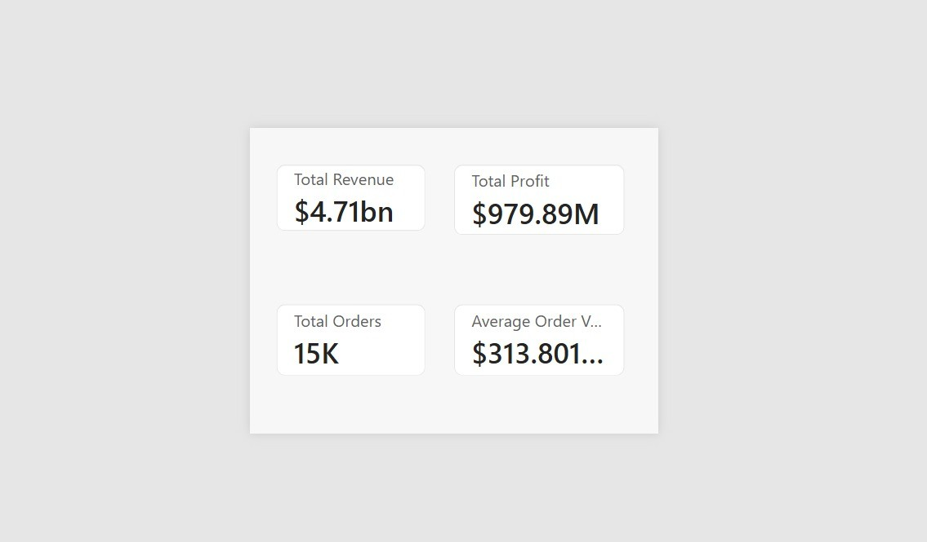

Slicers and Interactive Filters
The dashboard includes five visible filter controls:
- Year – narrows the report to a selected calendar year. The available data spans 2024, 2025 and part of 2026.
- Store type – compares channels such as Online, Urban, Flagship, Mall and Suburban.
- Product category – focuses the visuals on a selected product group.
- State – filters the store and revenue analysis by state.
- Customer segment – allows analysis by customer groups such as Regular, Occasional, Premium and Value.
These controls make the dashboard interactive. When a selection is changed, the KPI cards and connected charts can be used to inspect the selected portion of the dataset rather than only the overall totals.

Supporting Data Overview
The uploaded files contain 15,000 sales fact rows representing 15,000 distinct order IDs, 1,000 customers, 190 products, 13 stores and 80 salespeople. The date dimension contains 731 dates. The store dimension includes online and physical store records.
The dashboard KPI totals reconcile closely with the sums in fact_sales. The dim_order table contains an order-level total_amount field whose aggregate is different from the fact_sales total_amount aggregate. For this report, the revenue and profit KPIs follow fact_sales because those are the measures displayed in the screenshots. This distinction should be retained when building or checking Power BI measures.
76

Key Findings
The screenshots and uploaded CSV files support the following observations:
- Overall revenue is approximately $4.71B and total profit is approximately $979.89M.
- The dashboard represents 15,000 distinct orders and 112,353 units of quantity sold.
- The calculated average order value is approximately $0.31M.
- The overall profit-to-revenue ratio calculated from fact_sales is approximately 20.82%.
- Online is the largest store type, contributing approximately $3.25B or 69.02% of revenue.
- Mobile Phones and Laptops are the two largest product categories in the CSV-based product join, at $1.77Band $1.46B.
- Mumbai is the leading physical city in the joined city analysis, at approximately $256.16M.
- October 2024 is the highest month in the available monthly aggregation, at approximately $256.36M.
- The revenue-by-store chart is dominated by Online Store, while the store table allows comparison of revenueand profit across individual locations.
- The monthly chart includes a partial January 2026 period, so its last point is not a full-month comparison.
Together, these findings show how the same transaction dataset can be examined through overall performance, product mix, store type, geography, store-level results and monthly trends.

Conclusion
The Sales Performance Dashboard demonstrates how Microsoft Power BI can turn multiple related business tables into an interactive visual report. KPI cards provide a quick summary of revenue, profit, orders and quantity, while charts make it easier to compare product categories, store types, cities, stores and monthly performance.
The use of slicers for year, store type, product category, state and customer segment supports more focused analysis. The project also provides practical experience in importing CSV data, relating fact and dimension tables, selecting suitable visualisations and interpreting business measures.
Overall, the dashboard presents a consolidated view of sales performance and provides a useful starting point for exploring revenue and profitability across the business.

References
- Microsoft Power BI Desktop.
- Uploaded sales dataset CSV files: fact_sales, dim_order, dim_product, dim_store, dim_city, dim_state,dim_customer, dim_salesperson and dim_date.
- User-provided Sales Performance Dashboard screenshots.
- NEW REPORT.pdf (used as the report structure and formatting reference).

